Solving 1st order DE using Matrix Method

EXPERIMENT - 5

CODE: -

clc

clear all

syms x c1 c2

c=[c1 c2];

A=input('enter the matrix A in dy/dx=Ay+h: ');

h=input('enter h as a column vector in dy/dx=Ay+h');

n=length(A);

[P,D]=eig(A);

PP=inv(P);

g=PP\*h;

for i=1:n

u(i)=c(i)\*exp(D(i,i)\*x)+(exp(D(i,i)\*x)\*int(g(i)\*exp(-D(i,i)\*x)));

end

y=simplify(P\*transpose(u));

disp('the solution is given by')

disp(y)

Input 1: -

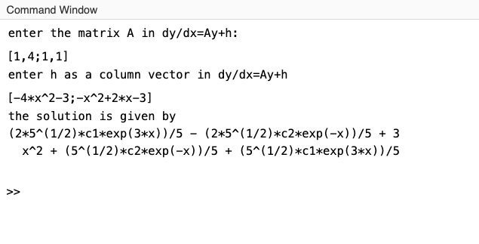

Input 2: -

QUESTION: -

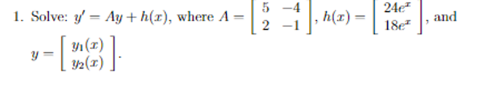

COMMAND WINDOW: -

